Chapter 19, Problem 33.

Obtain the h parameters for the two-port of Fig. 19.91

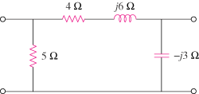

Figure 19.91
For Prob. 19.33.

